**LEBANESE AMERICAN UNIVERSITY**

**USAID – HIGHER EDUCATION SCHOLARSHIP PROGRAM**

**HES - Volunteering Program Verification Form**

This form is to be used to document volunteering hours. If a student volunteers for multiple organizations, a separate form must be used for each organization. **This form must be turned in by the 28th of each month, the latest.**

I certify that the scholar Ali Zaghlan El Hajjar completed a total of 5 hours of service at InnovaThrive.

The hours were completed hours as per the below:

Hours # 2 (date) _2/12 – 6/12_ (initials of supervisor) __A.K.___

Hours # 1 (date) _9/12 – 13/12_ (initials of supervisor) __A.K.___

Hours # 2 date) _16/12 – 20/12 (initials of supervisor) __A.K.___

Hours # 0 date) _23/12 - 27/12 (initials of supervisor) __A.K.___

Brief description of the activities the scholar performed or participated in:

As the IT manager, Ali Hajjar was responsible for overseeing the management and uploading of research papers to the drive. He ensured that the files were well-organized and easily accessible, streamlining the process for seamless collaboration. His attention to detail in structuring and maintaining an efficient system helped facilitate smooth access to important documents, enhancing overall productivity and organization within the team.

Written feedback about the scholar’s performance:

As an IT manager, Ali demonstrates strong organizational and technical skills by managing and uploading research papers efficiently. His attention to detail in ensuring seamless access and proper organization of documents highlights his ability to streamline workflows and maintain an orderly digital environment.

Please rate the overall performance of the scholar at your organization:

|  |  |  |  |
| --- | --- | --- | --- |
|  | Mastery (5) | Proficient (3) | Emerging (1) |
| **Problem solver** | X |  |  |
| **Engaged & Committed** | X |  |  |
| **Open-minded & multicultural** | X |  |  |

Signature

& stamp

__________________________

_

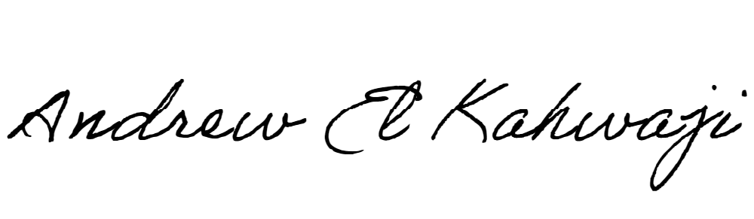

Printed Name _Andrew El Kahwaji_

Date __26/12/2024___

Email __andrew.lifesculptor.coo@gmail.com __

Phone __+961 71 914 378__